Pupil Premium Report 2018 - 2019

Overview | The Pupil Premium is designed to ensure that funding to tackle disadvantage reaches the pupils who need it most. The funding is allocated to Local Authorities and schools with pupils from Reception to Y11 who are eligible for free school meals (FSM), are looked after, adopted or have parents currently in the Armed Forces. In 2018-19 the funding allocated was £1320 per ever6 child, £300 for children of Armed Forces families and £2300 for adopted children ( £31245)
Total amount allocated to the school for the current academic year. | £29180 in total based on 1 x looked after child at £2300, 19 x Ever6 children at £1320 and 6 services pupils at £300 per child
Explain how the previous year’s allocation was spent 2018-19 | - Literacy and numeracy sessions delivered through evidence based intervention groups including First Class @ number (parts 1 and 2), Success @ Arithmetic, Better Reading Partnership Program, Literacy A to Z, Inference Training, Success @writing (pirate and dragon), Write away together.  - Small group tuition (Booster Maths and Writing Groups)  - Subsidised educational trips and opportunities to participate in a wide range of activities eg music lessons, breakfast club, brass band, choir, after school activities, theatre visits and residential trip.  - Pastoral and academic support for individual pupils through individual target-setting meetings, FRIENDs program counselling and 1:1 support.  - Staff development in order to provide evidence-based interventions and share good practice  - Specialist sports coach at lunchtimes and a weekly after school sport provision  - Family support and information sessions e.g. class cafes/ workshops/ information sessions/homework club  - Play therapy and counselling support for pupils
How will the money be spent this academic year 2019-20 | - Literacy and numeracy sessions delivered through evidence based intervention grps including First Class @ number (parts 1 and 2), Literacy A to Z, Success@ arithmetic, First Class @ writing 1 & 2, Better Reading Partnership, Reading inference,  - Small group tuition (Booster Maths and Writing Groups)  - Subsidised educational trips and opportunities to participate in a wide range of activities e.g. music lessons, brass band/ ukulele lessons, choir, sports clubs, breakfast club, after school activities and theatre group visits.  - Pastoral and academic support for individual pupils through individualised target-setting, FRIENDs program and counselling.  - Staff development in order to provide evidence-based interventions and share good practice (phonics,  - Play therapy and counselling support for pupils  - Specialist sports coach at lunchtimes and a weekly after school sport provision  - Family support and information sessions e.g. class cafes/ workshops/ information sessions/ parent forum
Statement about the effect of the expenditure on the educational attainment of those pupils who were eligible for pupil premium | There is a higher number of pupil premium children in Year 2 than in other year groups in the school. Of these children there is 60% that are also SEN.  Attainment of children across the year groups:  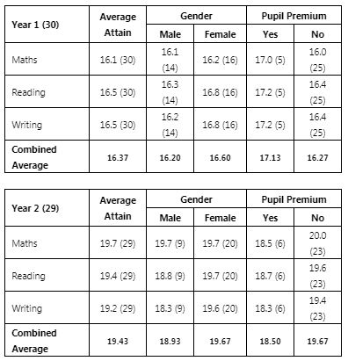  Year 1 pupil premium children have made excellent attainment across all of the core subjects. They are working beyond their peers in each subject.  Year 2 have 60% of the pupil premium children who are also SEN registered. This shows when the attainment is compared between pupil premium and non-pupil premium children. They are working below their peers in all areas of learning. Reading is the one area where the gap is slightly less between pp and non-pp.  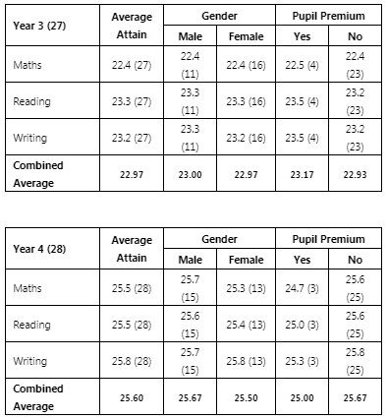  Year 3 and 4 pupil premium children are in line with their peers in all areas of learning. 50% of children in Year 3 are from forces families and have achieved exceeding across the curriculum. Both year groups have a lower percentage of pupil premium children who are also SEN.  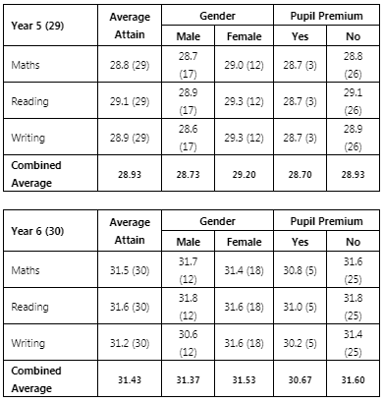  Although Year 5 have 50% of their pupil premium also on the SEN register, they are closely in line with their peers. (One child is not included in the data as he moved to another school at the end of the summer term)  Progress Data  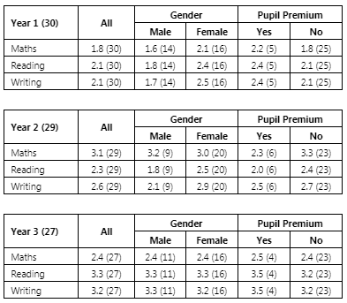  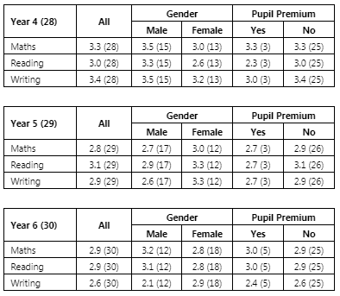  Writing  First Class @ writing in Year 3 & 4 saw a dramatic impact on pupil confidence in writing, writing competence and length of written work.  Early Years  Disadvantaged pupils made expected or better rates of progress from their starting points in line with non-pupil premium pupils. 100% of PP children met the GLD at the end of the reception year.  Attendance  Attendance of all pupil premium pupils in 2018-19 is on track or above non-pupil premium children, except for some year groups.. Those where the attendance is lower by pupil premium pupils compared to their peers, there has been recognised and unavoidable illness. The school has worked closely with the EWO and prompt actions have caused an increase in attendance, by some pupils. Meetings have occurred between the school and parents/carers to address the issue. One family who have a child in Year R and Year 5 have caused the attendance data to dramatically lower in these year groups.  Behaviour  Only 10% of all incidents recorded, are from pupil premium children. 1 pupil premium child who has ADHD receives one-to-one support throughout the day and this has lowered the rate of incidents.  Additional information  The newly allocated SLT member who has taken the role of Pupil Premium Champion is presently on maternity leave. This role has been taken on temporarily by Dawn Deacon the Deputy Head Teacher until May 2020. The school is receiving a pupil premium audit September 2019, by the local authority. The school has also stream-lined its tracking systems of pupil premium children to enable each PP child’s provision to be set and tracked.
  Pupil Premium Data 2018-19
  Year | Y |  | N
  Year R | 2 | 7% | 26 | 93%
  Year 1 | 5 | 17% | 25 | 83%
  Year 2 | 6 | 21% | 23 | 79%
  Year 3 | 4 | 15% | 23 | 85%
  Year 4 | 3 | 11% | 25 | 89%
  Year 5 | 3 | 10% | 26 | 90%
  Year 6 | 5 | 17% | 25 | 83%
  Year | Pupil Premium | Non-Pupil premium
  R | 90.3 | 96.25
  1 | 97.33 | 96.53
  2 | 94.74 | 96.53
  3 | 98.03 | 98.02
  4 | 95.35 | 97.35
  5 | 89.91 | 97.70
  6 | 96.96 | 94.21

