
ISLEHAM WEEKLY NEWS
Week commencing: Monday 12th March 2018


WONDERFUL WORLD BOOK DAY
It really was a wonderful World Book Day on the 8th March, with so many wonderful costumes for the ‘Best dressed book character’ award in each class judged by our visiting author Lou Treleaven. It was immensely difficult to judge in each class, but the list below indicates those who received a book token for their class…Well done to all who dressed up for the day.
Reception Class- Alfie who dressed as ‘Tractor Ted’ from the ‘Tractor Ted’ books
Year 1 Class- Elsa who dressed as ‘Evil Pea’ from ‘Evil Pea Rules’
Year 2 Class- Poppy who dressed as Biff from ‘Dogs don’t do Ballet’
Year 3 Class- Eva who was dressed as Mrs Trafe from ‘Billionaire Boy’
Year 4 Class- Isaac who dressed as Grandpa from ‘ Grandpa’s Great Escape’
Year 5 Class- Macy who dressed as ‘The golden ticket’ from ‘Charlie & the Chocolate factory’
Year 6 Class- Edith who dressed as ‘the lion, the witch AND the wardrobe’ from ‘The lion, the witch & the wardrobe’!
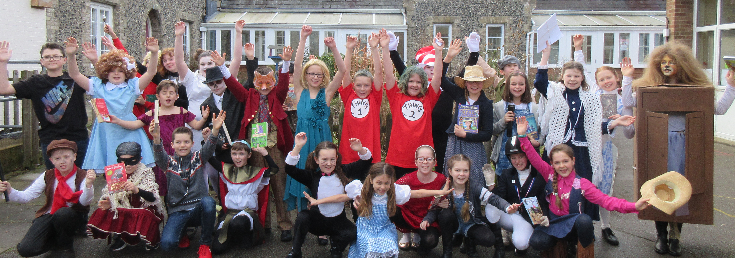
Thank you too for your support for our book stall, with all proceeds set to be forwarded to our partner school in Zambia- Taonga School.
With all best wishes,
Mrs Skillern
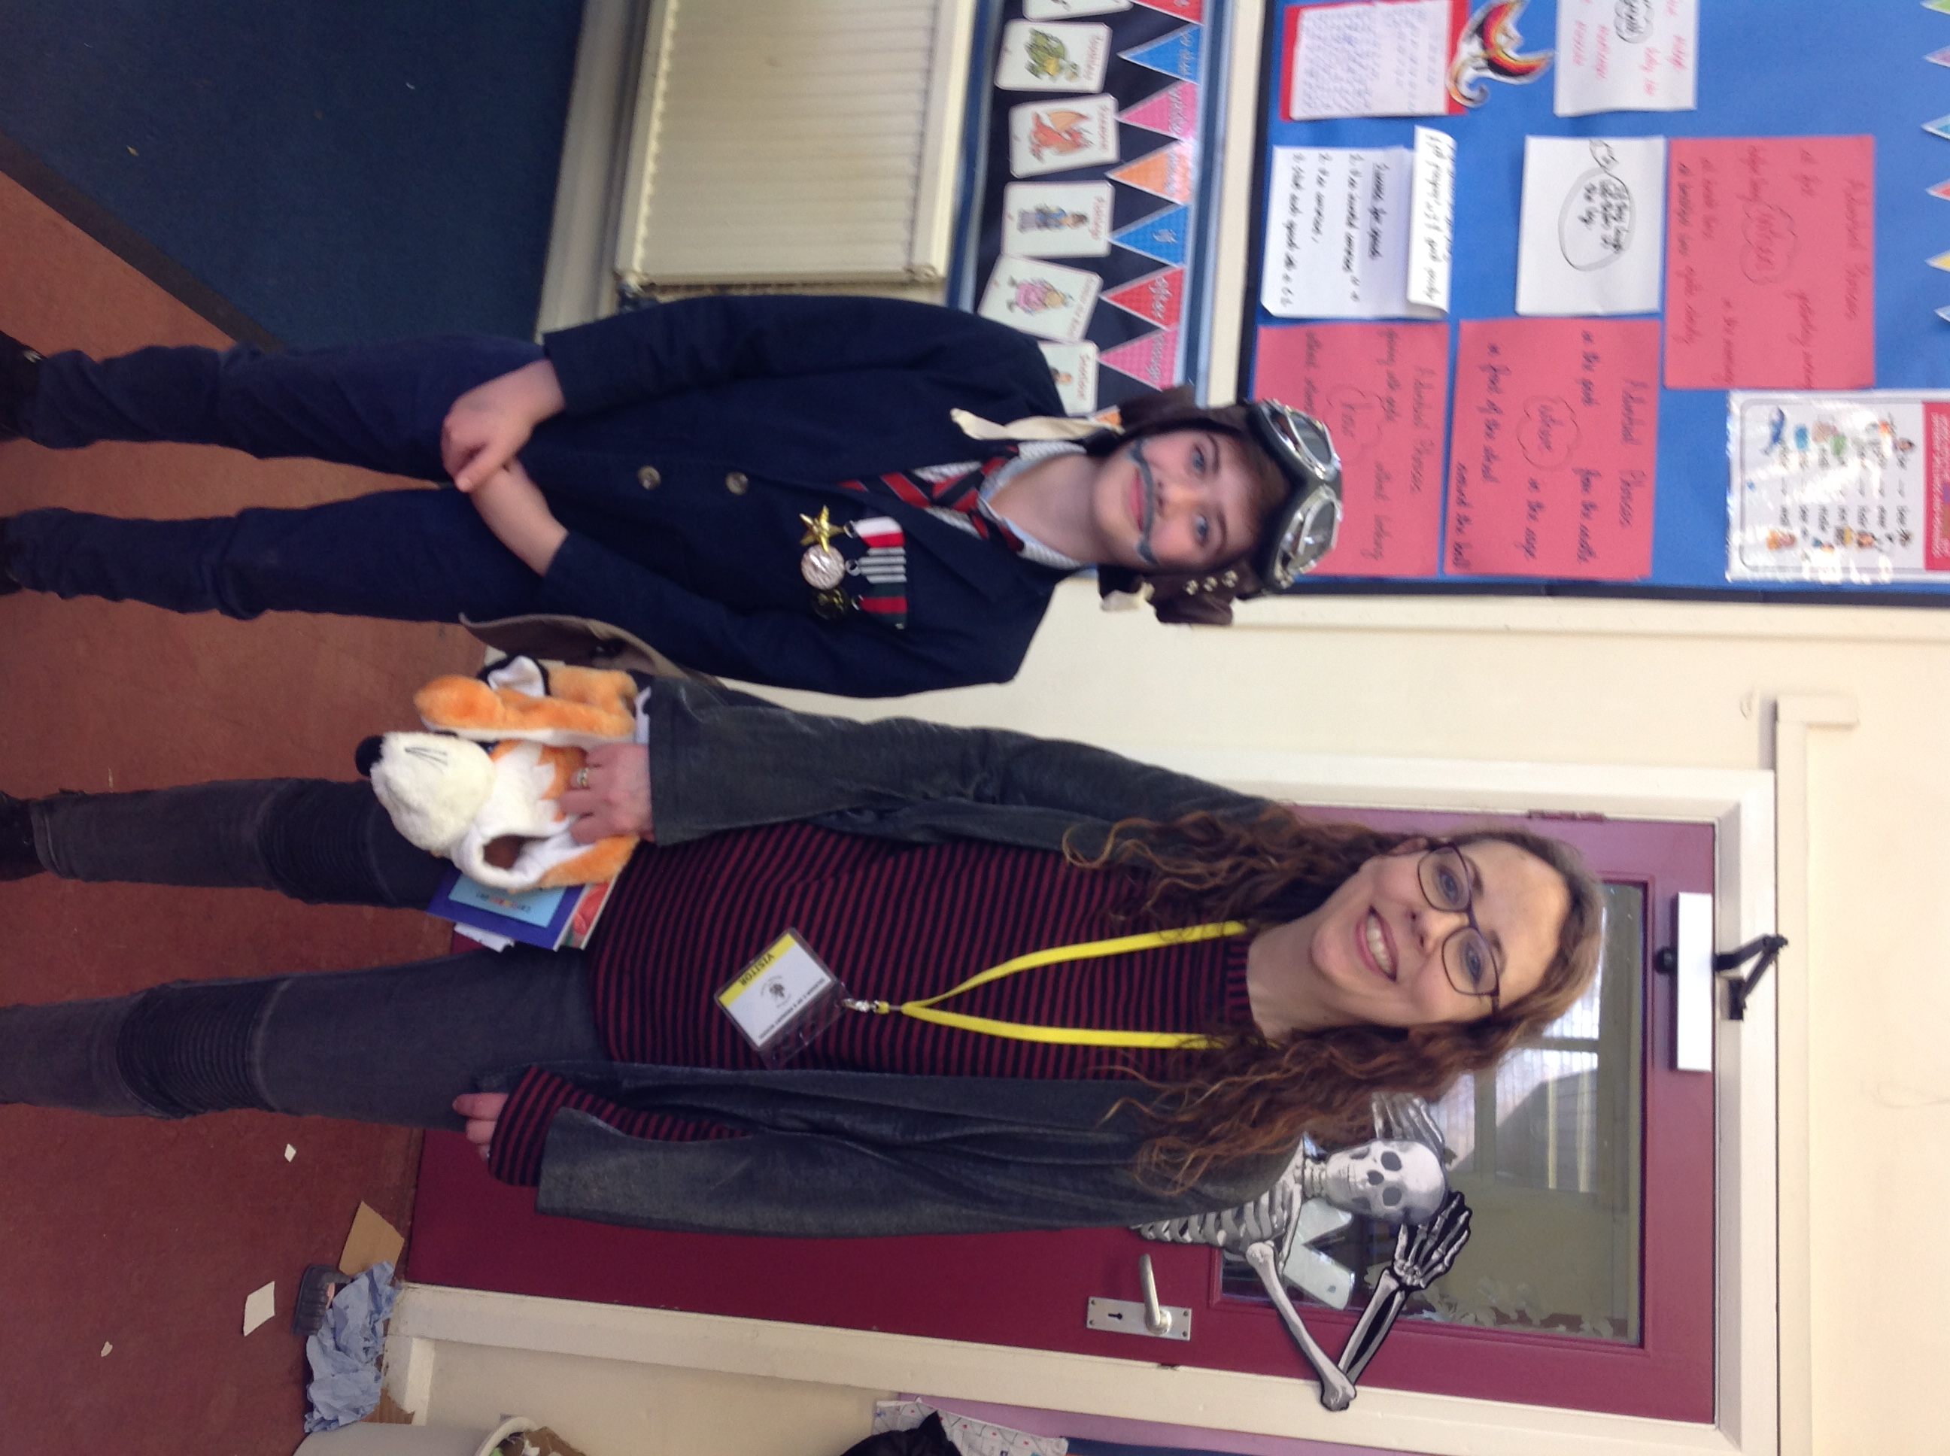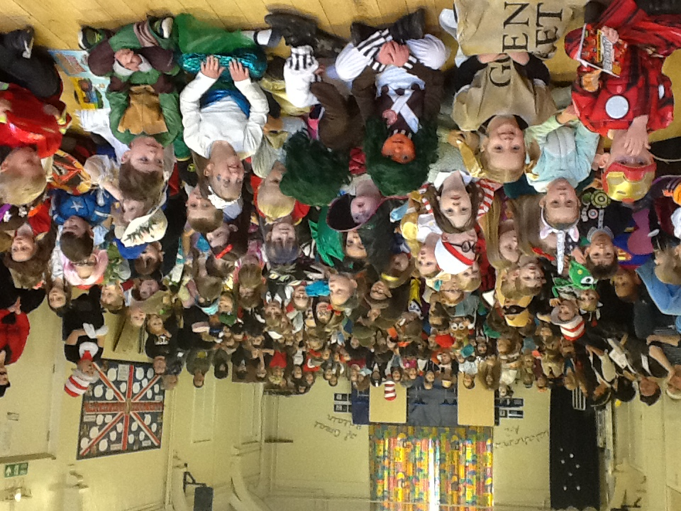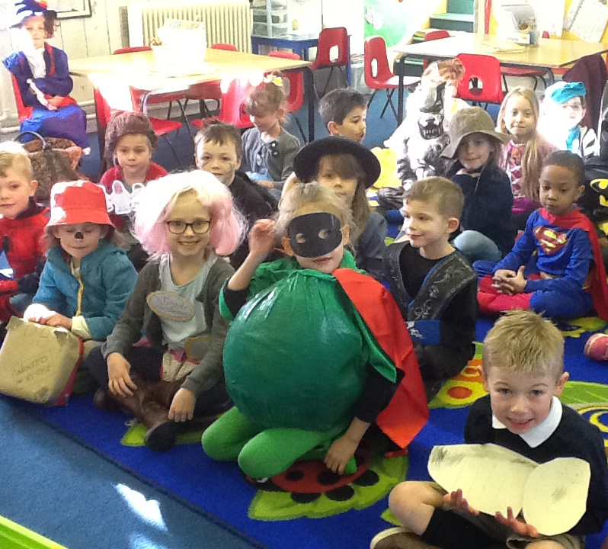
GALA PREPARATIONS 2018

I haven’t yet had any offers of floats for the Isleham Gala- if you can help, please let me know. We have been asked by the Isleham Gala Committee to consider if we can submit a school float for the Isleham Gala procession which is due to take place this year on Saturday 7th July 2018. I feel this will be very much dependent on whether there is anyone in the local area who can loan us (and drive for the procession!) either a tractor with trailer attached, or a flatbed truck. If you or anyone you know can offer this, please email head@isleham.cambs.sch.uk by Friday 16th March so that we can get in touch to make arrangements for the float. Thank you in advance.
TROTTING CHALLENGE
We are proud to announce that two of our Year 6 girls- Georgia and Faith- were featured in the Newmarket Journal recently for their horseriding fundraising efforts in aid of the East Anglian Air Ambulance. The trotting pole challenge held on Wednesday of half term in February involved the youngsters, who were all aged 13 and under, trotting their ponies over a set number of poles in a set time. The event took place in the outdoor arena at Palace House, which could soon be the base for a new riding club called Riding Riders. More than £800 was raised for this worthy cause. Well done girls for your hard work.
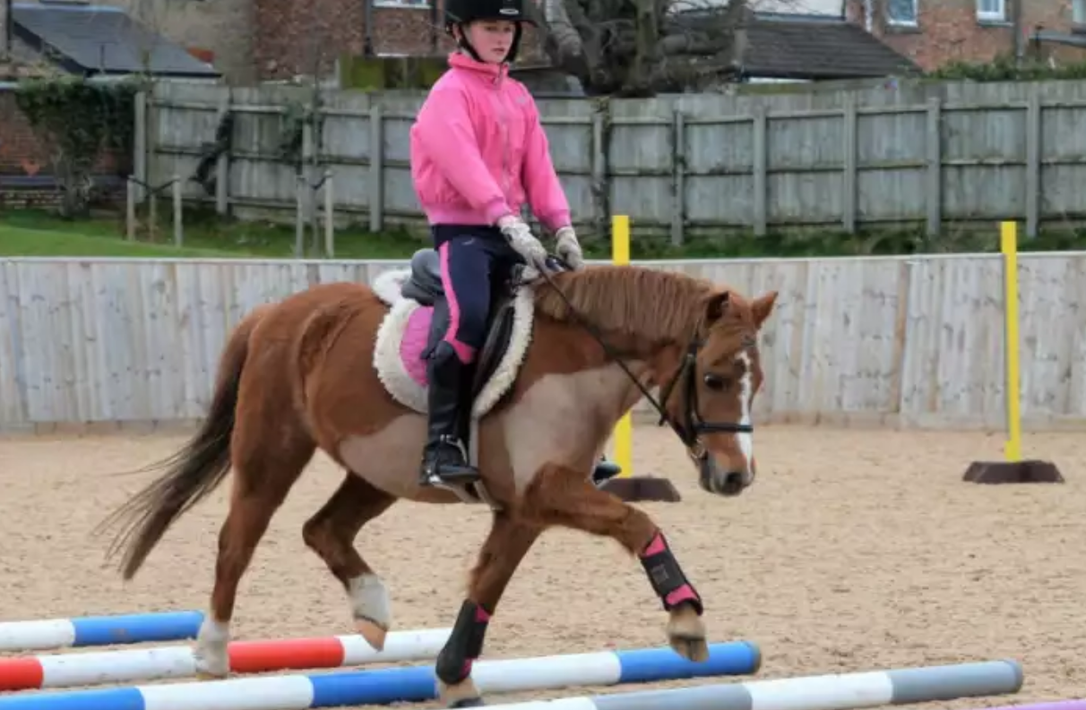

FINAL CLASS CAFÉ

Year 5 presented their Class Café for parents this morning and impressed with all their work and dancing skills. They also enjoyed sharing the new iPad TTRockstars (times tables) app with their parents. Well done to all the children.

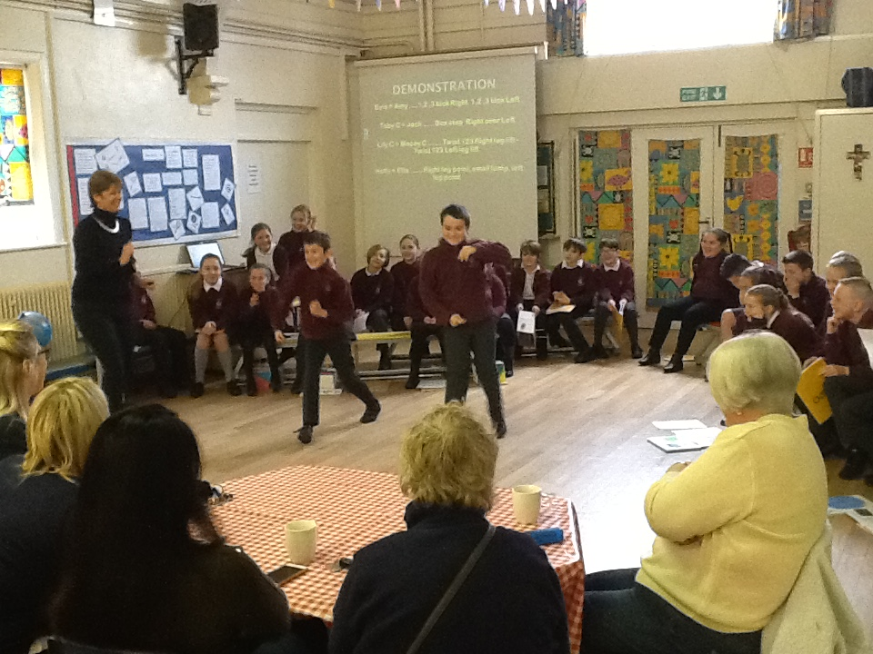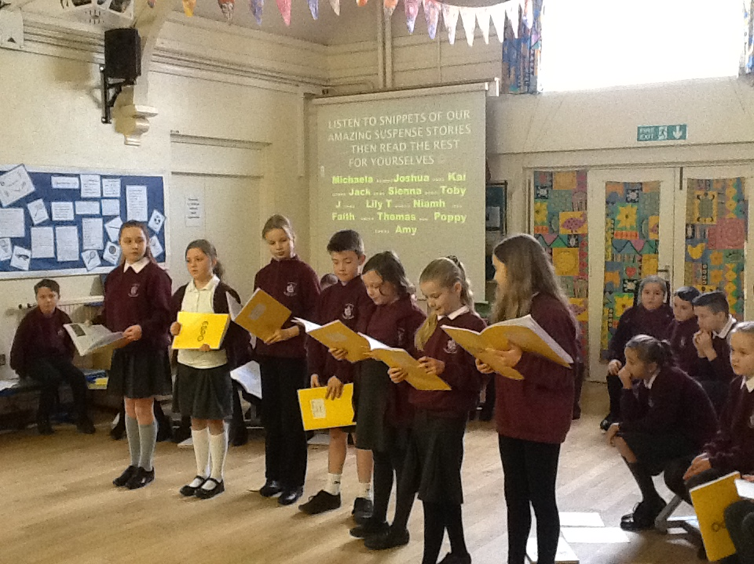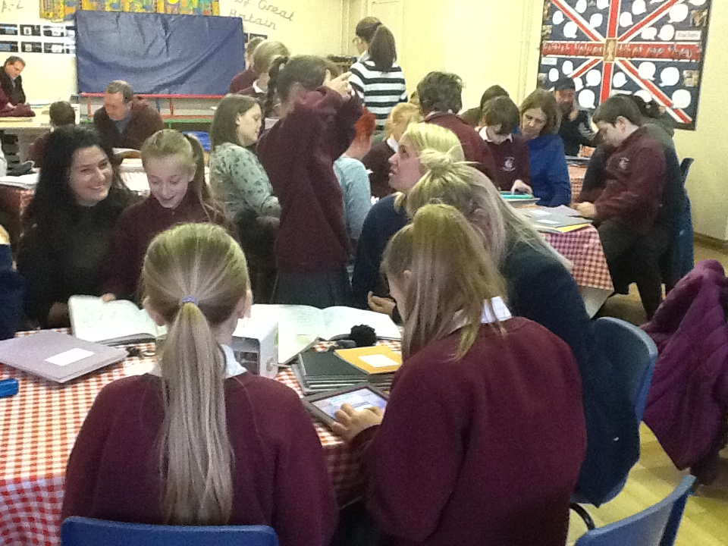

MOTHER’S DAY STALL AT ISLEHAM

Thank you to everyone who supported last week’s Mother’s Day stall- we hope all Mums, Aunts, Nans and Grandma’s had a lovely day and liked their presents.
BIRTHDAYS
Congratulations to the children who celebrate their birthdays this week:-


VALUE OF THE WEEK
In our assemblies this week and next, we are thinking about our school value of ‘Truthfulness’.

ISLEHAM SCHOOL SWIMMING POOL NEW LINER FUNDRAISING
As the summer term looms ever closer, work is already under way to prepare our school pool for the summer season 2018. This year, we have an additional expense of needing a new pool liner, costing over £4000. If you or anyone you know may be able to make a donation to support our school pool and keep it running, please visit our ‘Gofundme’ page and give what you can.
https://www.gofundme.com/isleham-school-swimming-pool-liner
MENU THIS WEEK
  
This week’s menu options are listed below:-.
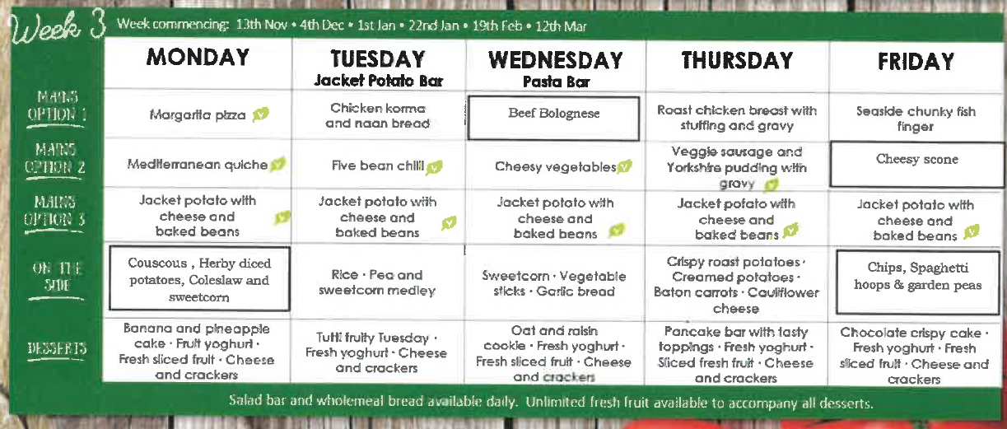
Shamrock Cookie
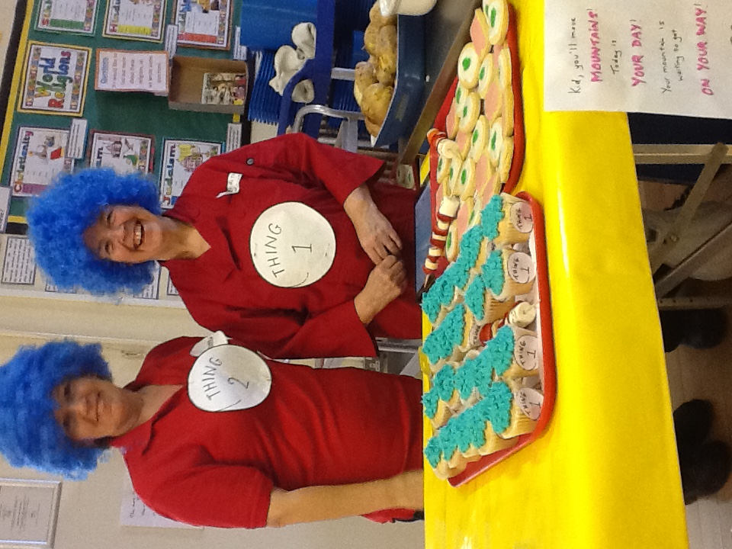
This Friday will be St Patricks Day lunch with a Shamrock Cookie for dessert.

Many thanks to the lovely catering staff for the lovely desserts on our recent belated St David’s Day and World Book Day.

HANDWRITING AWARDS
 

The recipents of the first weekly Handwriting award for 2018 last week were:-

Week commencing:- | Reception | Year 1 | Year 2 | Year 3
5th March 2018 | Thomas | Charlotte | Freya Mc | Belle

Well done to all four children for their super handwriting last week and throughout this school year.

SPRING TERM DIARY DATES
Monday 12th March- Year 5 Class Café 9am
Monday 12th March- Family worker drop-in
Wednesday 14th March- Year 5 visit to Science Ambassadors roadshow
Monday 26th March- No Clubs during week
Monday 26th March- 1.45pm- Yr 3 & 4 Production (dress rehearsal to rest of school)
Tuesday 27th March- 1.45pm- Yr 3 &4 production 1 of 2 (entry by ticket only)
Tuesday 27th March- 3.30pm- Resuscitation training- all teachers
Wednesday 28th March- 6.00pm- Yr 3 &4 production 2 of 2 (entry by ticket only)
Thursday 29th March- Break up for Easter holidays at end of school day- Own Clothes Day & cake sale
Monday 16th April- Staff Professional Development Day- School closed to pupils
Tuesday 17th April- Children back to school for the summer term
COMMUNITY NEWS
NOT LONG NOW UNTIL THE PANTO SHOW-STOPPER!


Don’t forget to book your tickets for this local Isleham show- tickets are still available from The Beeches, or there will be a 'portable ticket station' outside of the school grounds on Wednesday 7th and 14th March from 3 - 3.30 pm. There will also be prizes given out for the best children's fancy dress at each performance!

