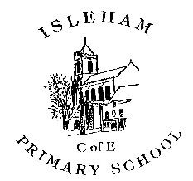
Progression of skills in Art & Design
EYFS- Expressive arts & design is a specific area of the EYFS curriculum
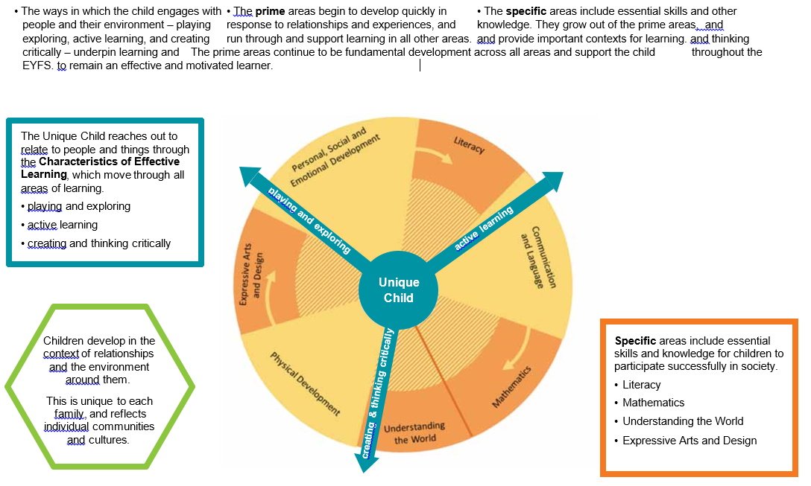

 | EYFS |  |  | Year 1 |  |  | Year 2 |  |  |  | Year 3 |  |  | Year 4 |  |  | Year 5 |  |  | Year 6
 | All about me  Pets  Fireworks/Diwali  Christmas | Superheroes and villains  Into the woods | Minibeasts  Animal Fair | Inventors | The Great Fire of London  Bodies | Nature  Royalty | Toys |  | Africa  Dinosaurs | The Seaside  Landscapes & Cityscapes | Romans  British Art | Africa | Van Gogh  Bodies | Greece | Stone Age | Autumn | Victorians Lowry | Textiles | Egypt | Wildlife and plants | South American Art
Exploring and developing ideas  (ONGOING) | ELG- children safely use and explore a variety of materials, tools and techniques, experimenting with colour, design, texture, form and function.  - Create simple representations of events, people and objects.  - Extend children’s experience and expand their imagination through the provision of pictures & paintings for stimulus  - Explores what happens when they mix colours.  - Experiment to create different textures.  - Understand that different media can be combined to create new effects.  - Use simple tools and techniques competently and appropriately.  - Select tools and techniques needed to shape, assemble and join materials they are using. |  |  | - Record and explore ideas from first hand observation, experience and imagination.  - Ask and answer questions about the starting points for their work, and develop their ideas.  - Explore the differences and similarities within the work of artists, craftspeople and designers in different times and cultures. |  |  |  |  |  |  | - Select and record from first hand observation, experience and imagination, and explore ideas for different purposes.  - Question and make thoughtful observations about starting points and select ideas to use in their work.  - Explore the roles and purposes of artists, craftspeople and designers working in different times and cultures. |  |  |  |  |  | - Select and record from first hand observation, experience and imagination, and explore ideas for different purposes.  - Question and make thoughtful observations about starting points and select ideas and processes to use in their work.  - Explore the roles and purposes of artists, craftspeople and designers working in different times and cultures.
Evaluating and developing work (ONGOING) | ELG- children safely use and explore a variety of materials, tools and techniques, experimenting with colour, design, texture, form and function.  - Chooses particular colours to use for a purpose.  - Select appropriate resources and adapt work where necessary.  - Manipulate materials to achieve a planned effect.  - Construct with a purpose in mind, using a variety of resources. |  |  | - Discuss what they and others have done and say what they think and feel about it.  - Identify what they might change in their current work or develop in their future work. |  |  |  | - Review what they and others have done and say what they think and feel about it.  - Identify what they might change in their current work or develop in their future work and give reasons.  - Annotate work in sketchbook. |  |  | - Compare ideas, methods and approaches in their own and others’ work and say what they think and feel about them.  - Adapt their work according to their views and describe how they might develop it further and give reasons.  - Annotate work in sketchbook. |  |  |  |  |  | - Compare ideas, methods and approaches in their own and others’ work and say what they think and feel about them.  - Regularly reflect and analyse their progress taking account of the purpose and what they had hoped to achieve.  - Adapt their work according to their views and describe how they might develop it further.  - Annotate work in sketchbook. |  |  | - Compare ideas, methods and approaches in their own and others’ work and say what they think and feel about them.  - Provide a reasoned evaluation of both their own and professionals' work, which takes into account the starting points, intentions, approaches and context behind the work.  - Regularly reflect and analyse their progress taking account of the purpose and what they had hoped to achieve.  - Adapt their work according to their views and describe how they might develop it further, giving reasons.  - Annotate work in sketchbook.

 | EYFS | Year 1 | Year 2 | Year 3 | Year 4 | Year 5 | Year 6
Drawing | - Begin to use a variety of drawing tools to make marks.  - Use drawings to tell a story.  - Investigate different lines.  - Explore different textures.  - Encourage representations of people. | - Use a variety of tools, including- sketching pencils, colouring pencils, crayons, oil pastels, felt tip pens  - Begin to explore the use of line (straight and curved), shape and colour (dark and light).  - To use drawing to develop and share their ideas, experiences and imagination.  - I can draw people and objects from my memory.  - Observational drawing from an object. | - Understand the basic use of a sketchbook and use a sketchbook to gather and collect artwork.  - Experiment with and use different media, e.g. sketching pencils, pencils of different thicknesses, wax crayons, colouring pencils, chalk, pastels.  - Draw for a sustained period of time from the figure and real objects, including single and grouped objects.  - To record from first-hand observation and experience using multiple medias.  - Experiment with the visual elements; line, shape, pattern and colour.  - To choose colours appropriately for a purpose. | - Use their sketchbook to collect and record visual information from different sources including own research.  - Experiment with different grades of pencil.  - Plan, refine and alter their drawings as necessary.  - Use different media to achieve variations in line, texture, tone, colour, shape and pattern including charcoal, pencil, pen, coloured pencil, oil pastel, felt tip pens, OHP transparencies and pens, chalk and charcoal.  - Draw illustrations.  - Understand symmetry to draw a designs.  - Understand composition  - Use personal interests to inform design in a context.  - Explore designs in a style to fit purpose/context.  - Use research to inform a design  - To improve their art technique of sketching.  - Observation drawing  - Draw for a sustained period of time at their own level from the figure and real objects, including single and grouped objects. | - Collect images and information independently in a sketchbook.  - Record observations and use them to review and revisit ideas within a context  - Explore designs in a style to fit purpose/context.  - Plan, refine and alter their drawings as necessary.  - Use research to inspire drawings from memory and imagination.  - Use different media to achieve variations in line, texture, tone, colour, shape and pattern including pencil, wax crayons and rubbers.  - Using a pencil in an unconventional way and using a rubber to create a portrait.  - Trace a design | - Use a sketchbook to develop ideas.  - Use a variety of source material for their work.  - Work in a sustained and independent way from observation, experience and imagination.  - Explore the potential properties of the visual elements, line, tone, pattern, texture, colour and shape.  - Use different media to achieve variations in line, texture, tone, colour, shape and pattern including pencil, charcoal and pens with detail.  - Observe natural objects linked to an artist.  - Alter and refine drawings and describe changes using art vocabulary.  - Make informed choices in drawing including paper and media.  - Develop use of symmetry in a complex design.  - Explore designs in a style to fit purpose/context.  - Use research to inspire drawings from memory and imagination.  - To investigate the materials and processes involved in drawing  - Explore pencil marks using varying grades of pencils and shading in various black tones.  - Cross hatching, stippling etc.  - Draw for a sustained period of time for observation drawing  - Create movement in a drawing  - To improve skills of drawing with a clear sense of perspective.  - Use a ruler to create architectural drawings. | - Demonstrate a wide variety of ways to make different marks with dry and wet media.  - Identify artists who have worked in a similar way to their own work.  - Develop ideas using different or mixed media, using a sketchbook.  - Manipulate and experiment with the elements of art: line, tone, pattern, texture, form, space, colour and shape.
Painting | - Experimenting with and using primary colours  - Naming/ mixing colours.  - Learn the names of different tools and different sized implements that can be used to paint.  - Create different textures e.g. using sand. | - Use a variety of tools and techniques including the use of different brush sizes and types to suit a purpose.  - To use line drawing and paint in combination.  - Work on different scales.  - Create backgrounds in a variety of media including watercolour paint.  - To create pattern with paint.  - Using colour, pattern, texture, line, shape, form and space in the context of making a painting from primary, secondary colours and extending to tertiary colours.  - Create a colour field painting.  - Mix and match colours to artefacts and objects.  - Mix secondary colours and shades using different types of paint. | - Use a variety of tools and techniques including the use of different brush sizes and types to suit a purpose.  - Identifying shapes and colours and the way they can be used to create images.  - To investigate and use the visual elements of line, colour and space in a painting.  - To create textured surfaces for painting.  - Collecting and selecting lines and patterns for their work.  - Developing brush control and pattern making.  - Name different types of paint.  - Work on a range of scales e.g. large brush on large paper etc.  - Mix secondary colours and shades using different types of paint  - I can mix colours, tints and shades.  - To use other media to create paintings including fingers and sponge  - To explore different brushstrokes.  - To use a paintbrush to apply dye to change the colour of the fabric.  - To understand and begin to use perspective. | - Mix a variety of colours and know which primary colours make secondary colours.  - Use a developed colour vocabulary.  - Work confidently on a range of scales e.g. thin brush on small picture etc.  - Mix and match colours using artefacts and objects.  - To investigate and use the visual elements of line, colour and space in a painting.  - Collecting and selecting lines and patterns for their work.  - Developing brush control with variety of sized brushes.  - Use a variety of tools and techniques including the use of different brush sizes and types to suit a purpose.  - Name different types of paint and their properties.  - Create a work of art using different media- iPad painting | - Make and match colours with increasing accuracy and explain how it has been made.  - Use more specific colour language e.g. tint, tone, shade, hue.  - Choose paints and implements appropriately.  - Plan and create different effects and textures with paint according to what they need for the task.  - Show increasing independence and creativity with the painting process.  - To use a variety of materials for painting including teabags, watercolour paint, soil paint, charcoal and powdered paint.  - Scratch paint off a surface to reveal a different media.  - To use natural resources as brushes.  - Paint using the same technique as a famous artist.  - Explore shape in architecture to form art. | - Make and match colours with increasing accuracy and explain how it has been made.  - Demonstrate a secure knowledge about primary and secondary, warm and cold, complementary and contrasting colours.  - Work on preliminary studies to test media and materials.  - Create imaginative work from a variety of sources. | - Create shades and tints using black and white.  - Choose appropriate paint, paper and implements to adapt and extend their work.  - Carry out preliminary studies, test media and materials and mix appropriate colours.  - Work from a variety of sources, inc. those researched independently.  - Show an awareness of how paintings are created (composition).
Printing | - Rubbings  - Print with variety of objects  - Print with block colours  - repeating patterns | - Carry out different printing techniques e.g. printing with objects, relief printing, negative prints, clay slab relief printing and collograph printing.  - To explore direct printmaking with a variety of objects and overprinting using primary colours.  - Exploring the use of different tools and surfaces for printing.  - To combine printing techniques already learned to produce a layered printed image.  - To print onto a variety of different surfaces including paper and fabric. | - Use a variety of techniques, including. carbon copy printing, relief, clay slab relief printing and rubbings with increasing accuracy and complexity.  - Design patterns of increasing complexity and repetition.  - Print using a variety of materials, objects and techniques.  - Exploring the use of different tools and surfaces for printing.  - To print onto a variety of different surfaces including paper, prepared backgrounds and fabric. | - Print using a variety of materials, objects and techniques including block printing.  - Describe and explain the processes used to produce a print.  - To explore pattern and shape, creating designs for printing within a context.  - Select appropriate tools and techniques.  - Mark out, cut and shape materials.  - Test print before final printing to adapt and improve method/application.  - Consider how colour can indicate an emotion | - Research, create and refine a print using a variety of techniques.  - Select broadly the kinds of material to print with in order to get the effect they want  - Detailed and complex relief printing with range of materials.  - Printing onto a variety of backgrounds.  - Overlay prints  - Work into prints with a range of media e.g. pens, colour pens and paints | - Explain a few techniques, including- relief printing and screen-printing (resist print).  - To use marbling in combination with screen-printing.  - To use a print in a repeating pattern.  - Printing onto a variety of backgrounds.  - Choose the printing method appropriate to task.  - Build up layers and colours/textures.  - Organise their work in terms of pattern, repetition, symmetry or random printing styles.  - Choose inks and overlay colours. | - Describe and use varied techniques.  - Be familiar with layering prints.  - Be confident with printing on paper and fabric.  - Alter and modify work.  - Work relatively independently.
Textiles/collage | - Handling, manipulating and enjoying using materials  - Sensory experience  - Simple collages  - simple weaving | - Use a variety of techniques including- printing onto fabric.  - Create images from imagination, experience or observation.  - Use a wide variety of media for collage, including- photocopied material.  - Using colour, pattern, texture, line, shape, form and space in the context of making a collage from primary colours.  - To create a collage about own work. | - Use a variety of techniques, including weaving, fabric crayons and wax or oil resist and batik.  - To create textured surfaces for painting including hessian, corrugated card and paper.  - To use simple stitching to apply decoration to a textiles product.  - To use a paintbrush to apply dye to change the colour of the fabric.  - Make a simple mosaic. | - Use a variety of techniques, including printing, dying (tie-dyeing).  - Name the tools and materials they have used and explain the reasons they selected it.  - To create a mosaic collage using paper, foam and develop to use stone and grout.  - Experiment with different materials  - To understand and use symmetrical pattern in a mosaic.  - Consider size and shape to form a collage. | - Match the tool to the material.  - Combine skills more readily.  - Refine and alter ideas and explain choices using an art vocabulary.  - Use glass mosaic with grout and select appropriate shapes and sizes for final piece. | - To investigate and reform visual and tactile qualities using construction and deconstruction  - Develop understanding through direct experience and manipulation of materials and processes.  - Develop individual responses to problem solving  - Develop an understanding of the nature of materials and matching this to their intentions.  - Develop an understanding of wax resist and control of tools.  - Apply knowledge and understanding through individual responses.  - Adapt and modify work through reflection of experience gained.  - Layering  - Construction and deconstruction  - Joining  - Constructing a relief panel  - Develop and explore the batik method.  - Compare ideas and approaches. | - Awareness of the potential of the uses of material.  - Use different techniques, colours and textures etc when designing and making pieces of work.  - To be expressive and analytical to adapt, extend and justify their work.
3 D form | - Handling, feeling, enjoying and  - manipulating materials  - Constructing  - Building and destroying  - Shape and model | - Use a range of materials creatively to design and make products.  - Manipulate clay in a variety of ways, e.g. rolling, kneading and shaping.  - Explore sculpture with a range of malleable media, especially clay.  - Experiment with, construct and join recycled, natural and man-made materials.  - Explore shape and form.  - Construct sculpture from materials collected.  - Collaborative sculpture with others. | - To use a range of materials creatively to design and make products.  - Understand the safety and basic care of materials and tools.  - Experiment with, construct and join recycled, natural and man-made materials more confidently.  - Manipulate clay in a variety of ways, e.g. rolling, kneading and shaping.  - To make a clay printing tile with details.  - Sculpt with different materials.  - Consider the size of a sculpture and the material sizes to create it.  - Make a simple papier mache object.  - I can paint my sculpture.  - I can use the technique of carving. | - To use a range of materials creatively to design and make products and give reasons for their choices e.g. textures and tonal materials to make different sensory effects, Modroc and paper.  - Understand the safety and care of materials and tools.  - Join clay adequately and work reasonably independently.  - Construct a clay base for extending and modelling other shapes e.g. make a clay tile – shape, and create parts to join.  - Use clay tools and cross hatching to join clay pieces together to form one piece of clay.  - Consider the size of a sculpture and the material sizes to create it.  - To develop ideas to make a maquette- small scale model use to help visualize and test ideas for larger sculpture.  - Use maquette to adapt ideas. | - Make informed choices about the 3D technique chosen.  - Show an understanding of shape, space and form.  - Plan, design, make and adapt models.  - Talk about their work understanding that it has been sculpted, modelled or constructed.  - Use a variety of materials.  - To create a clay coil pot  - Clay slip to join clay  - To use natural materials – true to the context.  - To use clay to form a variety of shapes  - Portable 3d art made from an unusual material  - Newspaper armature and Modroc.  Clay coil pot | - Describe the different qualities involved in modelling, sculpture and construction.  - Use recycled, natural and manmade materials to create sculpture.  - Plan a sculpture through drawing and other preparatory work.  - To use clay tools safely and confidently to produce products.  - Make a 3d model for a purpose from papier mache. | - Develop skills in using clay.  - Make a mould and use plaster safely.  - Create sculpture and constructions with increasing independence.

 | Year 1-6
Breadth of study | - Work on their own, and collaboratively with others, on projects in 2 and 3 dimensions and on different scales.  - Use ICT  - Investigate different kinds of art, craft and design.

