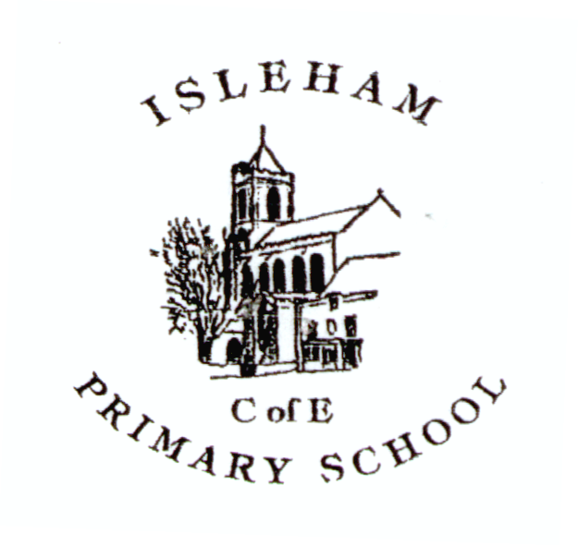
School Uniform Order Form

Name: ………………………………….. Telephone no: ………………..

Child’s Name: …………………………… Year: …… Date: …………..

Fleeces
£11.50 S youth M youth L youth XL youth XXL youth
(3-4 yrs) (5-6 yrs) (7-8 yrs) (9-10 yrs) (11-12 yrs)

Sweatshirts
£9.25 S youth M youth L youth XL youth XXL youth
(3-4 yrs) (5-6 yrs) (7-8 yrs) (9-10 yrs) (11-12 yrs)
£10.00 S Adult

Cardigans S youth M youth L youth XL youth
£11.20 (3-4 yrs) (5-6 yrs) (7-8 yrs) (9-10 yrs)

Polo Shirts - burgundy
£7.75 3-4 yrs 5-6 yrs 7-8 yrs 9-11 yrs 12-13 yrs
£8.50 S Adult

P.E. T Shirts - burgundy
£5.50 3-4 yrs 5-6 yrs 7-8 yrs 9-11 yrs 12-13 yrs
£5.75 S Adult

Shorts
£5.00 22” /24” 26”/28” 30”/32”

P.E. Bag
£4.50

Water Bottles £1.50 Water Bottle tops £0.30

Orders can be collected from the school office on Wednesdays after school
Prices correct at time of printing

Online Payment Authorisation Code: ..................................... Transaction No: .....................................

Order Collected: ..................................................... Date: ..............................

