Behaviour Policy

Isleham Church of England Primary School

September 2020

1.Introduction
Our school is a community of pupils, teachers, teaching assistants, lunchtime staff, governors,
parents/carers and other adults. A community works best where there is mutual respect between all
members and an agreed code of conduct within which all activities take place. It is our aim to ensure that every member of our school community feels valued and respected, and that each person is treated fairly and well, having equal opportunity to learn. We believe in equity as shown in the image below.
Table 1.1 Equality v. Equity (Cambridgeshire Steps, 2019)
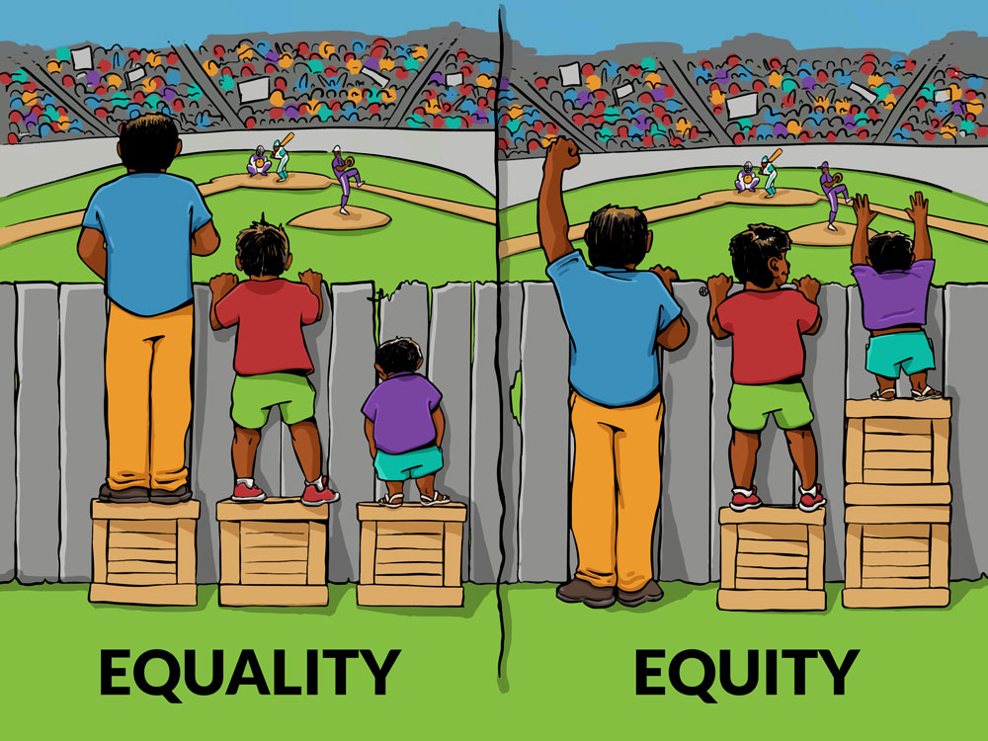

We believe it is essential to provide the support each child needs to thrive. We are a caring community, whose values are built upon mutual trust and respect for all. This positive behaviour policy is designed to support the way in which all members of the school live and work together effectively.

2. What are the principles or ethos that underpins the promotion of effective behaviours for learning at Isleham Church of England Primary School?
The school follows and teaches the following Christian Values for life:-
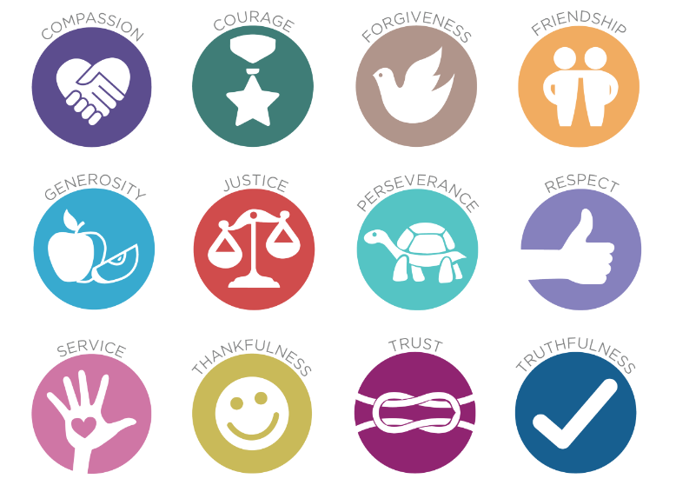
Table 2.1: Christian values by ‘Imaginor’ as adopted by Isleham Primary School, 2016

The school follows the Cambridgeshire STEPs (Step-On) programme, for which all staff are trained annually- “The process of taking necessary steps to ensure that every young person is given an equality of opportunity to develop socially, to learn and to enjoy community life.” (Cambridgeshire STEPs December 2019). We promote a therapeutic approach to behaviour management, prioritising pro-social experiences, feelings and behaviours in our pupils in school (‘the roots which lead to the desired fruits’) yet recognising that for some pupils who have experienced more antisocial experiences than others in their lives, more support may be required to behave pro-socially in school.

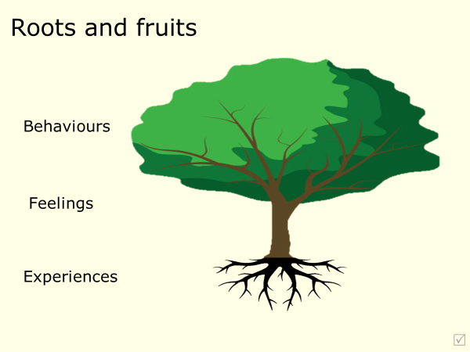
Table 2.2: Roots and fruits

3. What are the purpose and aims of the policy?
At Isleham Primary School we aim:
- to recognise, promote and reward positive behaviour.
- to work in partnership with parents and carers to support the social and academic development of all pupils.
- to provide a framework to support and promote socially acceptable behaviour.
- to promote an environment where Christian values are respected and followed
- to ensure staff focus on de-escalation and preventative strategies rather than focusing solely on reactive strategies.
- to ensure staff know how to manage difficult or dangerous behaviour, and to have an understanding of what challenging behaviour might be communicating.
- to ensure that all members of the school community ensure that they promote the school vision
- to focus and plan to manage stable behaviour (the pro-social behaviours that any individual is capable of displaying) and to recognise, plan and respond to escalating behaviours in order to prevent harmful behaviour. “Key phrase -CATCH THEM GETTING IT RIGHT” (Cambridgeshire STEPs)

4. What is the framework at Isleham Primary School which supports and promotes positive behaviour?
We use a three-stage framework to manage potential challenging behaviours. Staff are trained regularly to be equipped with the skills needed at each stage:

Table 4.1. Stage Skills needed:
Stage 1: | Before a crisis. | De-escalation.
Stage 2: | During a crisis. | Management of risk or harm.
Stage 3: | After a crisis. | Reflect, repair and restore (forgiveness).
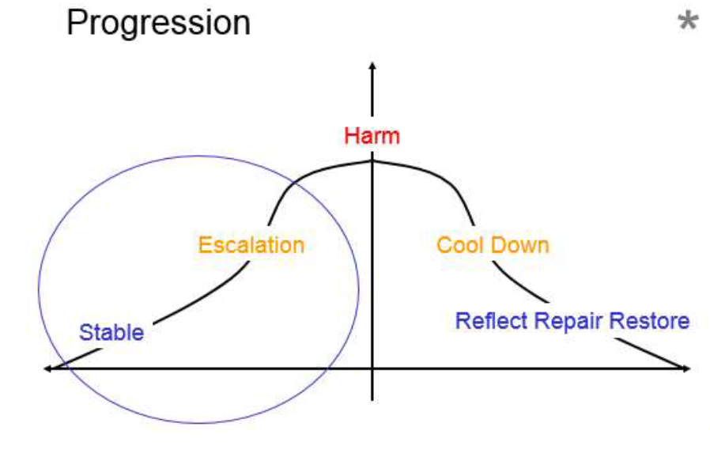

At Isleham Primary School, we believe that inappropriate behaviour contrary to school expectations should be dealt with using consequences (see Table 4.2), which have opportunities for the child to learn from their actions. We endeavour not to use punishments which could lead to further negative behaviours. We have developed a clear yellow and red card system for behaviour which is outlined in this policy, for use both in school and outside on the playground. In all situations where a child has not behaved in line with the school’s behaviour code, he or she will be given a yellow or red card and an opportunity to discuss the situation with an adult when they are able to, to repair and restore what has happened, and to verbalise what they will do differently should the situation occur again, before returning to play/ class/ any given situation/ activity. This is to support the child’s internal discipline and future response and avoid behaviour being guided purely by extrinsic motivators or regulators.
Sometimes a protective consequence, such as a removal of a freedom, is required to manage inappropriate behaviour, especially if there is a risk of harm. In extreme cases, where a child presents a high level risk, to ensure no further harm occurs in the short term, the child may receive a fixed term exclusion and/or a Risk Management Plan which aims to develop responses to de-escalate and avoid high level interventions occurring. If a child’s behaviour continues to result in harm to learning and the child has been unsuccessful with the educational consequences put in place, this may in very rare instances lead to a fixed-term or permanent exclusion. (See section, ‘What does exclusion mean?’).

Table 4.2 Examples of Consequences:

Educational Consequences | Protective Consequences
A note/ phone call to parents/carers/child to explain what the child did, why it was inappropriate and what the child should  do next time to make the right choice.  Completing tasks.  Rehearsing.  Assisting with repairs.  Educational opportunities.  Research.  Restorative meeting. | Isolation/removal from an area.  Increased staff ratio.  Limited access to outside space.  Escorted in social situations.  Differentiated teaching space.  Removal from classroom.  Exclusion.

“Generally the concept of ‘discipline’ is linked to an attitude of prosecution and the idea of apportioning blame. Steps encourages services to adopt an attitude based on the principles of pastoral care, closer linked to trying to understand and a defence for the child’s actions. Punishment is unhelpful as it only has the potential to suppress rather than change conscious behaviour and can have no positive effect on subconscious behaviour. Steps encourages staff to have a more constructive view of discipline and to associate the term with internal discipline which is working with individuals so they understand and value pro-social behaviours. Working with children’s experiences and feelings is likely to have a far greater impact on behaviour. This approach creates internal discipline.” (Cambridgeshire STEPs, 2019)

5. What are the school’s expectations of behaviour?
- we speak and listen to each other politely.
- we show tolerance and respect each other’s right to be different.
- we treat each other with respect at all times.
- we promote good behaviour and self/internal discipline.
- we promote behaviour that prevents bullying.
- we promote behaviour to ensure that all children are able to complete their learning.
- we promote behaviour which helps regulate the conduct of other children.
- we promote an environment where no one deliberately sets out to make another person feel uncomfortable or unhappy.

6. What are the school rules?
To support all in our school community, everyone follows a set of golden rules.

ISLEHAM’S GOLDEN RULES

BE SAFE
BE RESPECTFUL
TRY YOUR BEST

Our expectations are also set out in the home-school agreement published annually in the front of each child’s home-school book. In addition, at the start of each school year, the class teacher will discuss with the children the values, routines and rules within the classroom. They will be agreed, displayed and referred to regularly.

7. How will positive behaviour be promoted?
The promotion of positive behaviours for learning is central to our school behaviour policy. We have a clear system of rewarding positive behaviour as follows:
- All members of the school community are encouraged to praise and congratulate each other. This may involve a small sticker or smiley face on work, or an approving look, words of praise or smile to show recognition of a child doing the right thing’- staff aim to spot children ‘getting it right’.
- Each week, the staff award a certificate for children who have gone above and beyond in class, in their work or behaviour in a weekly Celebration ‘Star of the week’ Assembly. This is attended by staff and children from throughout the school. House tokens are accumulated according to the star certificates given out to individuals with the winning house each term able to select a charity to benefit from any fundraising the following term.
- All children enjoy golden time on a Friday afternoon if they have not received any red cards.
- Any member of the school community can write a ‘Special Mention’ and put it into the “Golden Book”, to be read out at the celebration assembly for anyone who’s excellent behaviour, attitude or hard work has really stood out in a particular event that week
- Values and behaviour are reported upon to parents/carers at least termly in pupil’s verbal and written school reports, or during parent consultations.
- One of the school’s values or curriculum drivers will be promoted across the school each week.
- Support of parents/carers and pupils is secured through display and communication of expectations and the use of a home-school agreement
- The school acknowledges the efforts and achievements of all children, both in and out of school, through its weekly newsletters and web pages.

As part of their personal and social development the children will also participate in ‘circle time’/ ‘discussion time’. This time is devoted to enhancing self-esteem, self-discipline and positive relationships through planned age-appropriate structured class discussions. Children also participate in PSHE classes linked with circle time. These approaches benefit children as individuals and as members of the school family and provide an opportunity for children to share pleasures, worries, and fears and help them to learn to take turns and listen to others.

8. How can staff/volunteers teach behaviour?
- Positive relationships and positive body language.
- Role modelling.
- Consistency and Clear Expectations.
- Positive phrasing (see Table 8.1)
- Scripts and routines (see Table 8.2 for de-escalation script & Table 8.3 for examples of de-escalating body language).
- Planning provision to accommodate children’s needs
- Celebration and Recognition.
- Reward and positive reinforcement.
- Reminders of success.
- Limited Choices and Disempowering (see Table 8.1)
- Discussion and Task Support.
- Comfort and forgiveness.
Table 8.1 Examples of positive phrasing, limited choices and disempowering responses:
Positive Phrasing | Negative Phrasing
Stand next to me.  Put the book on the table.  Walk in the corridor.  Switch off the computer.  Walk beside me to the kitchen.  Stay seated in your chair.  Please/thank you. | Stop being silly!  Be good!  Don’t throw the pen!  Stop running!  Don’t talk to me like that!  Calm down!
Limited Choice | No Choice (making demands)
Where shall we talk - here or in the kitchen?  Put the pen on the table or in the box.  I am making a drink - orange or lemon?  Are you going to sit on your own or with the group?  Are you starting your work with the words or a  picture? | Get in here now!  Get out!  Do as you are told!  Give it to me now!  Open Choice: What do you want to do?  Would you like to go inside?
Disempowering the Behaviour | Empowering the Behaviour
You can listen from there.  Come and find me when you come back.  Come out from under the table in your own time.  Now you are in my office you can use those bad  words if you need to express yourself. | Come back here, NOW!  You are not allowed in there.  Get down from there!  Don’t you dare swear at me!  I will let you use the computer if……..
Positive Scripts | Negative Scripts
Classroom language.  Take turns.  Walking feet.  Listening ears.  Kind words.  Kind hands. | Do you think you're clever?  Do I look stupid?  What did you say?  Here we go again!  How many times…….
Example of a menu:
Positive Phrasing:
Come and sit next to me for a story.
(Repeat/Remind/Take-Up Time).
Limited Choice:
Would you like to sit on the chair or bean bag?
Disempowering the Behaviour:
You can listen to the story from there.
Consequence:
We will check you understand the story before going out for break time.

(Cambridgeshire STEPs, 2019)
Table 8.2 De-escalation script
De-escalation script is a prepared script to be used when a child is trying to engage adults or others in conflict. The script is:
1. Child’s name
2. I can see something has happened
3. I’m here to help
4. Talk and I’ll listen
5. Come with me and…
It is important that all staff use the same script, although it can be in a different order. The De-escalation script should be used repeatedly with no variation from it until the child has been persuaded to leave the situation and is no longer in an agitated state.
(Cambridgeshire STEPs, 2019)
Table 8.3 De-escalating body language
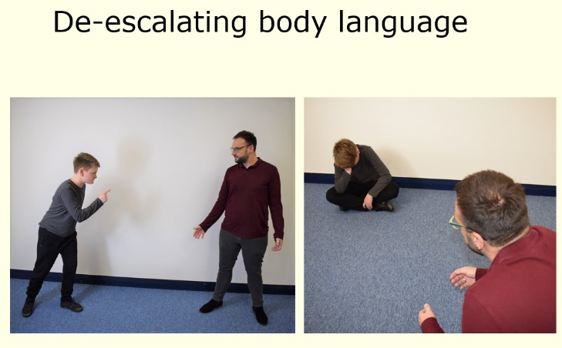
- Outside of an outstretched arm
- Good distance
- Standing to the side
- Relaxed hands
- Managing height
(Cambridgeshire Steps, 2019)

9.How will the school respond when children do not meet the expected level of behaviour?
(See table 9.1- Isleham’s behaviour pitch)
We recognise that all children may occasionally need reminders about how to behave in a positive way. Our behaviour response aims to understand why any antisocial behaviour is happening and give children multiple opportunities to understand what they need to do differently to succeed.

We want all children to be part of the class free choice and Golden Time on a Friday afternoon which they help to plan each week, so warnings and reminders are intended to enable that to happen. Staff will give at least 2 reminders to help children succeed. Staff will use a script similar to that in section 10 to ensure that we are consistent in helping children to understand when they are not behaving as expected, and that they know what to do to put it right.

Children who repeatedly break the rules (after warnings) or whose behaviour is significantly impacting others will receive a protective consequence- in the form of a Yellow card- time will be given for them to reflect upon and discuss what has happened with an adult and how this is impacting others. After any yellow card, the child may need to complete work missed or carry out some discussion time or a restorative task at playtime or 12.15pm-12.30pm lunchtime. Staff will ensure that each child has some time to run around outside if playtime is missed, and sufficient break and time to eat their lunch. Parents will be made aware of any yellow cards via a brief note in the home-school book but can be assured that the issue has been resolved in school and the child has discussed how to avoid any recurrence. Where children have received 2 yellow cards, this is the ideal time for parents to talk through with their child how they can help them to avoid any further yellow cards.
Children whose behaviour is serious and leaves the safety or wellbeing of themselves or others at risk, or whose behaviour has repeatedly resulted in 3 or more yellow cards in a week (Monday to Friday) despite warnings, will receive a red card. They will be given time to reflect upon what led to this situation and try to resolve how to avoid this happening again both on the day with the staff member present (as for yellow cards) and then with the Headteacher or Deputy during Golden Time. Loss of Golden Time is seen as a Protective Consequence where the children have a freedom removed. During this time, the Headteacher will be responsible for pastoral care and promoting opportunities for learning through discussion. Removal from Golden time is seen as an educational consequence to promote internal discipline. Parents will be made aware of any red cards via the home-school book and via a face to face conversation with or phonecall with the Headteacher or Deputy. The Headteacher or Deputy will log any red card incidents in the school’s incident book. The Headteacher or Deputy will be more than willing to speak to parents about restoration strategies and ways that parents can support their child at home.
Responding to repeated incidents of antisocial difficult or dangerous behaviour
RED CARDS- HEADTEACHER/ DEPUTY HEADTEACHER INVOLVEMENT
If the child’s behaviour results in “red cards” these will be logged in the school’s Incident Book by the Headteacher or Deputy Headteacher. Parents/carers will be contacted.
REPEATED RED- HEADTEACHER, SENCO & OUTSIDE AGENCIES
If the initial strategies are unsuccessful and the child’s behaviour continues to result in red cards, parents/carers will be contacted again on each occasion, and an appointment will be booked to discuss the situation with the class teacher and SENCo or Headteacher/ Deputy present, with a view to improving the behaviour of the child by implementing a Risk Management Plan. The child will be supported and monitored closely by staff. Further meetings will be arranged with parents/carers to discuss progress. If, over a set period of time, behaviour does not improve, outside agencies will be contacted for advice on how to further support the child.
FURTHER ACTION- SEN SERVICES & EXCLUSION TEAM
If the child continues to present with inappropriate behaviour after supportive strategies have been put in place, this may result in a fixed-term exclusion which may later lead to a permanent exclusion. Serious breaches of behaviour and discipline such as acts of intentional or deliberate physical assault, verbal abuse, stealing, use of weapons, damage to property, and absconding from school premises will result in an immediate phone call to parents/carers requesting a meeting with the Headteacher or Deputy Headteacher in her absence, as soon as possible, depending on the circumstances. The seriousness of the incident may result in a fixed-term exclusion of up to 3 days or a permanent exclusion. (see section 16) The consequences will be determined by evidence available to the Headteacher or Deputy Headteacher in their absence. All aspects of the case will be taken into account in this step and County guidance regarding exclusions will be followed.

10. Scripts for staff
All responses to children are intended to be as calm and private as possible to avoid public embarrassment and de-escalate the situation. However, when there are other pupils involved in a situation, they may of course become aware of another child being given a warning or card. We expect all children to support one another in aiming for Golden Time and in helping with any restoration work.

Yellow Card
Children who repeatedly break the school rules (after warnings) or whose behaviour is significantly impacting on others
Sample Script directly to the child:
Stop “name”
I need to write your name in the yellow card book because you are breaking this rule and hurting/ affecting others- this is what you should be doing and why.
Do you need some time to reflect on what has happened?
Once the child is ready:-
What happened and how were you feeling? How did others feel? (draw in others as needed) What can we do to avoid this happening again and get you back to gold behaviour?
Thank you.

Warning up to x 2
Children who are breaking the school rules and causing minor disruption to others
Sample Script directly to the child:
Stop “name”
This is a warning.
You are breaking this rule- this is what you should be doing and why.
Thank you.

Red Card
Children whose behaviour is serious and leaves the safety or wellbeing of themselves or others at risk, or whose behaviour has repeatedly resulted in 3 or more yellow cards in a week despite warnings.
Sample script directly to the child:
Stop “name”
Your behaviour is unacceptable and you will need to take some time to come and talk through what has happened and why. Let’s go to the office/ classroom. (Child escorted by staff member)
Thank you.
Sample script:
Do you need some time to reflect on what has happened?
Once the child is ready, talk-time offered:-
What happened and how were you feeling? How did others feel? (draw in others as needed) What can we do to avoid this happening again?
We need to record this incident in the school incident book.

Table 9.1- Isleham’s Behaviour Pitch
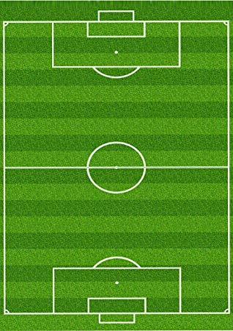

RED CARD
REFLECT, REPAIR & RESTORE
MISSED GOLDEN TIME
Headteacher/ Deputy Head involvement
Communicated to parents via home school book and conversation
3 yellow cards or SERIOUS ANTISOCIAL BEHAVIOUR =
YELLOW CARD
REFLECT, REPAIR & RESTORE
(Communicated to parents via home school book)
Isleham
Golden Time
WARNING & REMINDER
WARNING & REMINDER
11. What about children with diagnosed behavioural difficulties or specific needs?
Children who have diagnosed behavioural difficulties or specific needs (E.g. ADHD, ASD) may require an adjustment in this policy following a discussion with the Headteacher, SENCo, Outside Agencies and parents/carers in order to best meet the child’s individual specific needs and to support their well-being. In this instance, a behavioural plan will be drawn up clearly indicating the ways in which the child will be responded to when their behaviours are impacting on their own or others’ learning.

12. What items are banned in school?
If banned items are brought to school, be that intentionally or by unintentionally, the Headteacher (or Deputy Headteacher in her absence) will refer to Step 4-7 of the response charts. Prohibited items are defined in the Education Act 1996 and the Schools Regulation 2012 as:
- Knives or weapons, alcohol, illegal drugs and stolen items.
- Tobacco and cigarette papers, fireworks and pornographic images.
- Any articles that the member of staff reasonably suspect has been, or is likely to be, used to
commit an offence, or to cause personal injury to, or damage to property.
13. What happens if a child makes malicious allegations against school staff or other children?
Pupils that are found to have made malicious allegations will have breached the aims and expectations of behaviour listed in this policy. The school will refer straight to Steps 4-7 for an appropriate action and depending on the circumstances this will be referred to the police if there are grounds for believing a criminal offence may have been committed.

14. Physical intervention/ positive handling in the primary school
At Isleham Primary School, we are committed to ensuring all of our children are treated with care and respect- in line with the school’s Safe Touch policy, a child would and should only be physically ‘handled or restrained’ in accordance with the latest guidance by the DfE, by an adult in school in order to:
• prevent him/her from committing a criminal offence.
• prevent him/her from harming themselves or others (including physical and mental).
• prevent or stop him/her from causing serious damage to property.
Planned physical intervention in cases of extreme need should be:
• Agreed in advance by a team in consultation with the child and his or her parents/ carers.
• Planned in advance including broader strategies for addressing the child’s behavioural difficulties.
• Under the supervision of an identified member of staff.
• Subject to recording, reporting, monitoring and, if necessary, investigation.
Members of staff receive regular additional training through the Cambridgeshire STEPS programme about physical handling of pupils, at least annually. The training covers a range of areas, including conflict de-escalation, calm body language, debriefing opportunities for children following any anti-social behaviours and positive handling techniques. School staff will always follow this training and the schools’ ‘Safe Touch’ policy and parents are always fully informed about any situation that has arisen involving their child.
15. Physical contact permitted and agreed in our school
There are occasions however when we consider it completely natural and acceptable for some physical contact to occur between staff and children for a variety of reasons, for example:
• to comfort or congratulate a child
• to direct or steer a child
• for activity reasons (for example in drama, physical games, some musical instrument tuition)
Please see the school’s current Safe Touch Policy for further details of techniques used.

16. What does exclusion mean?
We do not wish to exclude any child from school but where there is sufficient evidence that
a pupil has committed a disciplinary offence/ serious misbehaviour (and allowing the pupil to remain in school would seriously harm the education or welfare of the pupil or others in the school), the pupil may be excluded from attending school for a fixed period or permanently. We use the current Cambridgeshire County Exclusions guidance which can be found on the cambslearntogether.co.uk website, to ensure that children, parents and staff understand the steps in this process.

Only the Headteacher, Deputy Headteacher or the senior leader in charge in the Head’s absence, has the power to exclude a pupil. Whilst not an exhaustive list, the following sets out the kind of serious misbehaviour that might lead to exclusion:-
    - persistent bullying
    - physical assault including violent behaviour
    - sexual misconduct
    - drug and alcohol related incidents
    - damage to property
    - theft
    - persistent disruptive behaviour, including non-compliance and failure to follow school rules.

Permanent exclusion will normally only be used as a last resort when all other reasonable strategies have been exhausted without success. However, some offences will be deemed so serious or affect the discipline and well-being of the whole school community that permanent exclusion for a first or one-off offence will be deemed by the Headteacher to be an appropriate response. These types of very serious behaviour include:
    - serious actual or threatened violence against another pupil or member of staff
    - sexual abuse or assault
    - supplying an illegal drug
    - carrying, threatening to use, or using an offensive weapon.

If the Headteacher excludes a child, they will inform the parents or carers within the prescribed timescales, using the agreed County guidelines, giving reasons for the exclusion. At the same time, the Headteacher will make it clear to the parents or carers that they can, if they wish, make representation or appeal against the decision to the governing body. The school will inform the parents or carers how to make such an appeal.
17. What about bullying?
Our school does not tolerate bullying of any kind. If we discover that acts of bullying or an act of
intimidation has taken place, the Headteacher will be informed, the incident will be logged and
parents/carers will be notified. While it is very difficult to eradicate bullying, we will do everything in our power to ensure that all children attend school free from fear. Please refer to the school’s current Anti-bullying policy.

18. Behaviour outside school
The school expects pupils to behave in a positive way at all times, including offsite and outside usual school hours whether or not they are under the direct supervision of school staff e.g. on a school trip/ at an evening school event such as a PTA disco. Whilst it would be rare for a child to receive a sanction in school-time for behaviour outside school hours, parents are asked to support the school in ensuring any antisocial behaviour does not go unchecked, and that children behave pro-socially both within school and within the local community.
19. Confiscation
The school may confiscate items such as mobile phones and sharp objects in certain circumstances. Appropriate arrangements for the return of these items will be made. If it was necessary, and in the interests of the health and safety of the pupils and staff, screening and searching of pupils for weapons will be conducted according to the 2014 Searching, screening and confiscation advice.
20. What are Outside Agencies?
- Cambridgeshire STEPs team
- SEN Specialist Teaching team
- Educational Psychology and Specialist Support
- Cambridgeshire County Council
21. What support is there for parents/carers?
- Family worker- Linda Beaton
- Cambridgeshire STEPs team
- Cambridgeshire County Council

22. How will this policy be monitored?
The Headteacher monitors the effectiveness of this policy on a regular basis (at least annually) and reports to the governing body on the effectiveness of the policy and, if necessary, makes recommendations for further improvements. This is done through the Headteacher’s Report to Governors at Full Governor’s Meetings, informal discussions when necessary and at the beginning of each school year at staff meetings for teachers and support staff.
The Headteacher keeps a record of any pupil who is excluded for a fixed-term, or who is permanently excluded.
It is the responsibility of the governing body to monitor the rate of exclusions, and to ensure that the
school policy is administered fairly and consistently.

23. What legislation does this policy refer to?
This policy has due regard to the following legislation, including, but not limited to:
- The Children Act 1989 & 2004
- The Childcare Act 2006
- Equality Act 2010
- The Education Act 2002, as amended by the Education Act 2011
- The Education and Inspections Act 2006 – Sections 88 and 89
- The Education (Provision of Full-Time Education for Excluded Pupils) (England) (Amendment) Regulations 2014
This policy also has due regard to the following guidance:
- DfE ‘Use of reasonable force in schools’ 2013
- DfE Behaviour & Discipline in Schools, 2016
- DfE ‘Working together to safeguard children’ 2018 (updated Feb 2019)
- DfE ‘Keeping Children Safe in Education’ 2019

24. Complaints about behaviour and discipline
Any complaints about behaviour and discipline will be dealt with under the school’s complaints procedure.

Last reviewed: 1.9.20
Date of next review: on or before 1.9.2021

