

Curriculum Planning Guidance

Isleham Church of England Primary School

April 2021

CURRICULUM

Curriculum Overview - INTENT

Our intention is that our curriculum extends opportunity; raises aspiration; opens children’s eyes to the world beyond their immediate environment; enables our children to live happy, healthy and productive lives and inspires children to learn more.

It is our vision that our curriculum gives our children the very best experiences to enable them to grow and develop as rounded individuals, with a wide and deep knowledge that they can use and apply in each subject and area in life.
At Isleham C of E Primary School we follow the National Curriculum and strive to enrich the curriculum wherever possible.

Our curriculum is focused on the development of children’s knowledge and skills across all primary subjects with the aim of ensuring pupils are ready for the next stage of their learning. Our families are key partners in developing their children’s knowledge and we are grateful to all our families who support their child’s learning. We are a reflective school and continually strive to improve our teaching and learning in light of the latest research and this has included a focus on how to improve children’s long-term memory of the knowledge provided in school. In Maths we follow a mastery approach where all pupils are taught to their year group expectation with challenge for the more able and support for those who need it.

As a Christian School we aim to value and respect every individual. We promote resilience, excellence and discovery. At Isleham, everyone can succeed and be the best they can be. We aim to provide an environment where all can flourish and let their light shine.

We learn about the following 12 Christian values to help us live and work together successfully:-
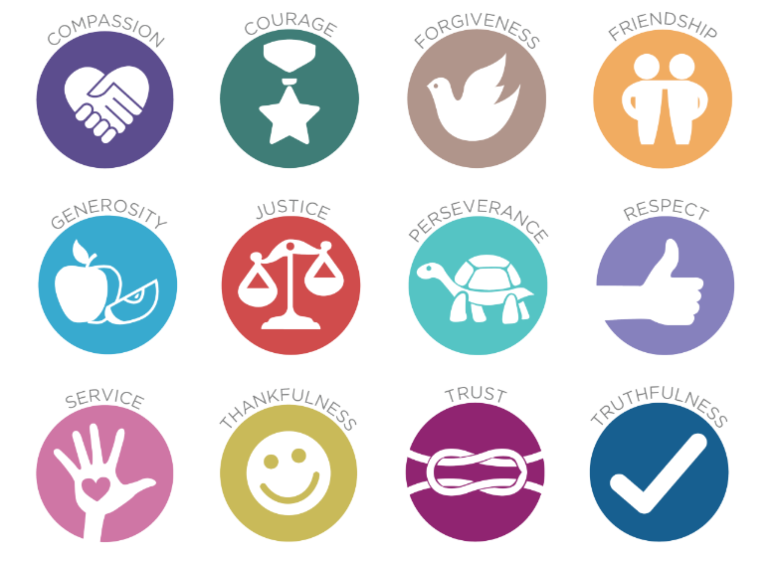

Our curriculum encourages our children to follow the school’s three key learning values:

- Resilience
  - We aim to build resilience and encourage a positive mind-set and characteristics of effective learning amongst our children. We embrace mistakes as it is often through mistakes that we learn the best.
- Excellence
  - We aim for all children to feel motivated to produce outcomes of the highest quality. We plan for and promote fluency in all core subjects. We maintain age-appropriate high expectations of effort, presentation and content in all outcomes. We celebrate success within school and we share this with the wider community.
- Discovery
  - We aim to promote learning through discovery in all areas of the curriculum. We broaden the experiences of our pupils through our engaging planning. We know that reading is the key to discovery and therefore embed reading for meaning and reading for pleasure into everything we do.
In their first year in school, our Reception children follow the Early Years Curriculum and develop their knowledge, skills and understanding through a combination of both play-based learning and more focused teacher led sessions. Pupils learn to share, work independently and play with others.

At Isleham, we are keen to promote the diversity of life and celebrate difference whilst promoting respect for all. Through our teaching, learning and behaviour expectations, we give pupils the knowledge and understanding of how discrimination and prejudiced behaviour is dealt with, including the prevention of bullying. The school takes opportunities to actively promote British Values of democracy; the rule of law; individual liberty; mutual respect and tolerance through our daily assemblies; our whole school systems and structures such as the annual election of House Captains and running a successful School Council. We also actively promote British Values through ensuring that our curriculum planning and annual calendar of extra –curricular events include real opportunities for exploring these values, for example our annual poppy wreath laying by House Captains at the village Remembrance Day service.

Curriculum Overview - IMPLEMENTATION

We have carefully selected a number of approaches to teaching and learning to meet the needs of our pupils and to raise standards. These include:
- The National Curriculum
- Power Maths
- Reading for Knowledge
- Reading for Pleasure
- Spelling Shed
- Letters & Sounds
- Big Cat Phonics
- Writing for Purpose
- STEPS Behaviour
- Class Dojo
- Zones of Regulation
- Cognitive Load Theory

At Isleham CE Primary School, we implement a number of enrichment days to promote our Christian Values, Learning Values or British Values. These include:
- House Days
- World Book Day
- Celebration Days
- Topic Dress-Up Days
- Young Voices
- Theatre Trips
- Science Week

Pupils with special educational needs are well-supported in school with extra support and/or resources deployed where necessary to help close individual learning gaps.

We also work towards meeting the aims of our curriculum in other ways. These include:

- Visits out of school and visitors into school. Visits include day trips and residential ones.
- Participation and involvement in and with our local community. For example, our involvement with Remembrance each year and our work with the elderly in our community.
- Extra-curricular clubs. Please see the clubs information on our website and in our weekly newsletters at the start of each term about our current clubs.
- Opportunities for children to experience responsibility and play and active role in the running of our school. For example as Sports Crew, Play Leaders and School Councillors.
- Activities with children from other schools. For example, sporting events, Young Voices, information exchange with other UK schools and music/ STEM/ maths challenges.

Curriculum Overview - IMPACT

Our curriculum can have the greatest impact in three main areas. These are:

Standards: The majority of children make expected or better progress towards their targets, which are set according to their baselines on entry.

Well-Being: Children enjoy learning and coming to school. Their mental health and wellbeing are prioritised and monitored closely. Support is put in place for those in need.

Personal Development: Children learn by our learning values and live by our Christian values. The outcomes and attitudes of our pupils demonstrate our mission. Behaviour is pro-social and safeguarding is excellent.

We are able to measure aspects of this. For example, we use statutory assessments and the progress children make to measure the impact of our English and Mathematics curriculum. We also measure the progress children make in other subjects, using our own tracking system.
In other curriculum areas, we can assess the impact through written work, outcomes and insights from children, from parents and our own observations show that children value the experiences we give them and that they help the children to learn and to grow in confidence, maturity and independence.
We keep the implementation and impact of our curriculum under constant review. We do this through our ongoing monitoring and evaluation work. The outcomes of this are used to help us adjust our curriculum regularly.

Assessment is used to identify children’s progress and find out areas where they are less confident. These assessments inform teacher’s lesson planning. Assessment is carried out across the curriculum through questioning, quizzes & brainstorming both before and after teaching. Children complete summative assessments termly to show progress in reading, writing and maths and to help teachers to tailor their planning to the needs of the class. We believe our curriculum prepares our children well for their secondary education and inspires them to find out more about the world around them. We aim to provide our children with the cultural capital they need to succeed in life. This cultural capital is enhanced through visits and events such as visits to the local environment, Young Voices, theatres and visitors such as children’s authors.

Senior leaders and subject leaders in the school can also monitor their areas of responsibility through:
- Statutory Assessment Data
- Pupil Progress Meetings
- Educater / Target Tracker
- Learning Walks
- Lesson Observations
- Lesson Study
- Self-Evaluation
- Surveys—parent, staff, child
- Subject Data
- Pupil Voice
- Peer Observations

Long Term Planning

An overview of the topics/subjects being covered in each class, each term and year, are recorded in the form of a curriculum map. This overview of Long Term planning is stored on the server under Staff share / planning/ and is also shared with parents via our school website and Class Dojo.

Medium Term Planning

Medium term plans (also known as a ‘pacer’) for each year group must be saved onto the school server (under Staff share / Planning / planning_19-20 / medium and short term planning 2019 / yr group by the end of the first week of each term.

These plans must include :-
Learning objectives, Brief outline of activities, Assessment opportunities/tasks, Learning outcomes (must, should, could), resources, key vocabulary, XC links including ICT, Health and Safety considerations and Curricular Targets (Maths, English and Science).

- Medium term plans can be taken directly from an agreed scheme of work and annotated appropriately for use by a particular class.
- Plans should be ‘Fit for purpose’ –useful to individual teachers, reflecting what they need to support their teaching of particular classes.
- For foundation subjects differentiation or ‘personalised learning’ approaches for individuals or groups of pupils can be highlighted / noted on teachers’ main planning documents.
- Other teachers should be able to understand the plans, for example, in order to use them to cover a lesson or as part of a scheduled classroom observation.

Short Term Planning
Short term planning for Mathematics largely follows the Power Maths DfE approved scheme. Short term planning for English (including reading, and writing) may be completed on the school’s provided proforma. Writing units of work should follow the ‘Three phase’ model which is outlined below.
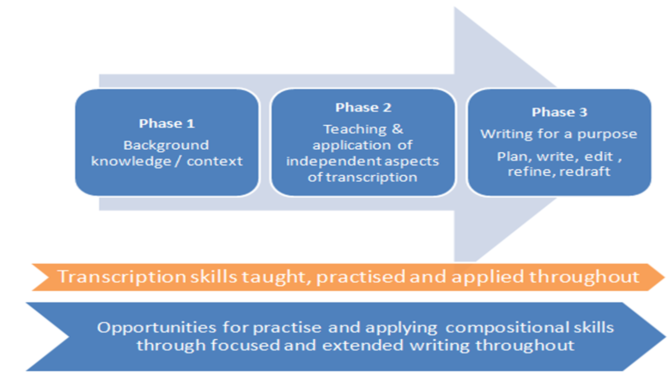
The length and duration of each phase will depend on the text type and year group. Each phase could last between 1-2 days up to 1-2 weeks.
In whichever form, it must contain the essential elements of planning, as outlined below.

Weekly, daily and individual lesson plans are derived from the learning outcomes from previous lessons/ formative assessment. Short term plans are related to specific groups and individuals. They must include:-
- the lesson objectives and success criteria ( these must be made clear to the class at the start of each lesson)
- tasks, resources (including the use of other adults), key vocabulary, ICT links
- differentiation (support, core and extension) and any special provision for SEN or G+T
- key questions for assessment / expected outcomes / plenary

The best way to see progress and learning is within the classroom, by talking to pupils and seeing the work in their books. Where progress is unclear, however, planning may be explored by any senior leader at any time in order to support the teaching of individuals, groups or whole classes. It is therefore required that all short term planning be saved to the server weekly to enable this process.

Last reviewed: 08.04.21
Date of next review: on or before 1.9.21

